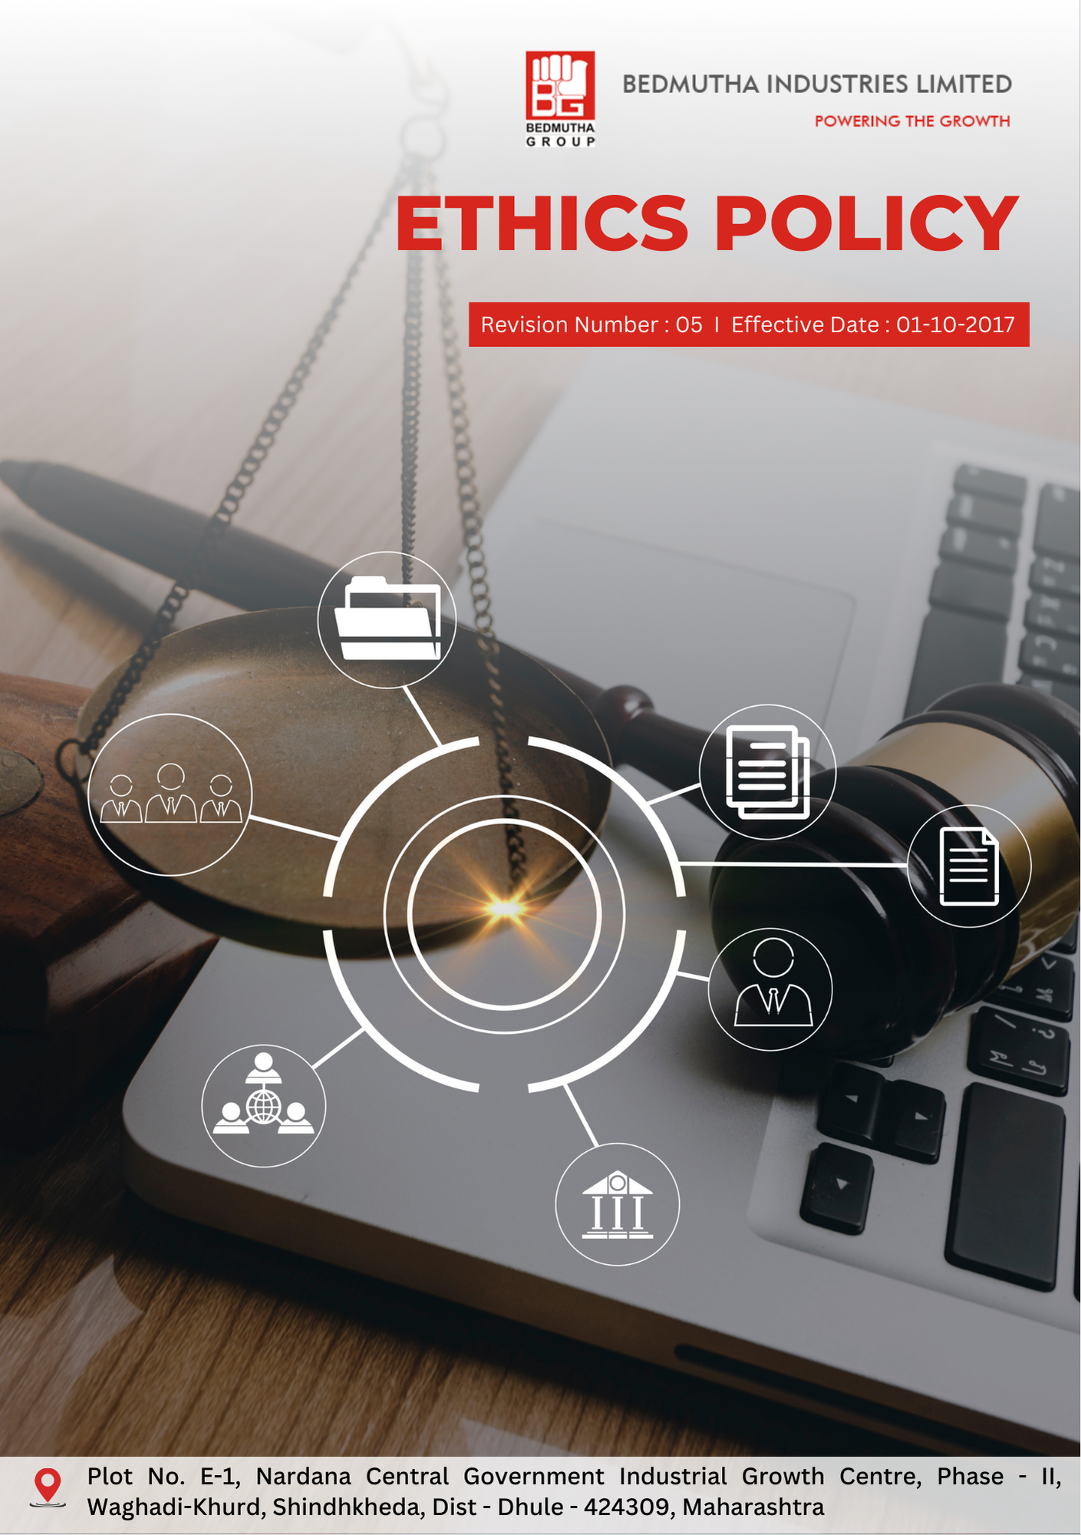

INDEX

1. Ethical Conduct Commitment 3
2. Promoting Integrity and Accountability in Operations 3
3. Scope 3
4. Responsibilities and Expectations 3
5. Specific Ethical Commitments : 4
6. Roles and Responsibilities: Governance Introduction 5
7. Disciplinary Measures for Policy Violations 7
8. Internal and External Reporting Mechanisms 8
9. Covered SDGs 8
10. Review Mechanism 9
11. Employee Acknowledgement Form: Ethics Policy : 10

Ethical Conduct Commitment
Bedmutha Industries Ltd is committed to conducting business with the highest standards of integrity, transparency, and accountability. This policy reflects our unwavering dedication to ethical behavior, ensuring that our operations, interactions, and business decisions align with core principles of honesty, fairness, and respect for all stakeholders. We strive to maintain a positive corporate culture that adheres to ethical conduct and legal compliance at every level of the organization.

Promoting Integrity and Accountability in Operations
At Bedmutha Industries Ltd, we focus on fostering an environment where all employees, suppliers, and stakeholders are empowered to act with integrity and accountability. We actively work to prevent unethical practices, ensuring that all business decisions are made with the highest respect for legal and moral standards. This includes a zero-tolerance approach toward corruption, fraud, money laundering, and all forms of unethical behavior.

Scope
This Ethics Policy applies to all employees, contractors, consultants, suppliers, and business partners of Bedmutha Industries Ltd, including all operations, facilities, and jurisdictions where the company conducts business:

Bedmutha Industries Ltd
Address: Plot No. E-1, Nardana Central Government Industrial Growth Centre, Phase -
II, Waghadi-Khurd, Shindhkheda, Dist - Dhule - 424309, Maharashtra.
http://www.bedmutha.com/

Responsibilities and Expectations
- Commitment to Ethical Standards
Bedmutha Industries Ltd upholds the highest ethical standards across all operations, ensuring adherence to legal, moral, and regulatory requirements in all areas of business, including anti-corruption, information security, and fair competition. We enforce ethical practices through the following actions:
- Conducting regular training on ethics, legal compliance, and anti-corruption measures for all employees and stakeholders.
- Ensuring compliance with relevant laws, including those related to anti-corruption, competition, fraud prevention, and money laundering.
- Establishing and maintaining clear channels for reporting unethical practices and ensuring confidentiality for whistleblowers.
- Engaging in transparent business practices, ensuring fairness and equal opportunity for all stakeholders.
- Monitoring compliance with this policy and taking appropriate actions for violations, including disciplinary measures.
- Reviewing the company’s business transactions for potential conflicts of interest and implementing safeguards to prevent unethical practices.
- Maintaining an open door for employees and external partners to report any issues of concern without fear of retaliation.

Specific Ethical Commitments :
- This policy establishes 2022 as the baseline year for measuring progress and achievements in our ethics initiatives.

- Corruption:
- Bedmutha focuses on ensuring 100% of employees, suppliers, and contractors complete annual anti-corruption training programs by 2026.
- The company aims to implement a digital monitoring system for detecting and preventing corrupt practices in all business dealings, targeting 95% compliance with global anti-bribery standards by 2026.

- Conflict of Interest
- The company plans to establish a conflict-of-interest declaration process, aiming for annual disclosures from 100% of employees in managerial roles by 2026.
- Bedmutha prioritizes integrating an automated system to monitor and flag potential conflicts in procurement and contracting, targeting 90% operational coverage by 2026.

- Fraud
- Bedmutha aims to reduce identified fraud risks by 30% by 2026 through annual fraud risk assessments initiated in 2026.
- The company focuses on training 100% of financial and operational employees in fraud detection and prevention techniques by 2026.

- Money Laundering
- Bedmutha emphasizes enhanced financial transaction monitoring systems, targeting 100% compliance with global anti-money laundering (AML) standards by 2026.
- The company plans to provide specialized AML training to all finance and procurement teams, ensuring effective identification and reporting of suspicious transactions by 2026.

- Anti-Competitive Practices
- Bedmutha prioritizes full compliance with local and international competition laws by 2026, supported by regular training programs for 100% of senior management and sales teams.
- The company focuses on establishing a compliance task force to monitor and review anti-competitive risks across all business functions, completing annual audits by 2026.

- Information Security
- Bedmutha is committed to implementing ISO 27001-compliant data security systems, ensuring 100% coverage of sensitive corporate and personal data by 2026.
- The company plans to conduct annual cybersecurity training sessions, aiming for full participation from all employees by 2026.

- Whistleblower Protection
- Bedmutha emphasizes the establishment of a confidential whistleblower hotline accessible 24/7, targeting a response time of less than 48 hours for all reports by 2026.
- The company focuses on resolving 95% of whistleblower reports within 60 days, ensuring fairness and transparency in the process by 2026.

Roles and Responsibilities: Governance Introduction
The governance structure at Bedmutha Industries Ltd for the Ethics Policy ensures a systematic allocation of responsibilities, fostering accountability, transparency, and adherence to ethical standards. This framework drives effective implementation and continuous enhancement of ethical conduct across all levels of the organization, reinforcing Bedmutha’s commitment to integrity, compliance, and stakeholder trust.

- The Board of Directors ensures the overall implementation and monitoring of the Ethics Policy, holding senior management accountable for compliance with ethical standards. They also review and approve policy updates and handle any significant violations.

- The Chief Compliance Officer (CCO) is responsible for leading the implementation of this policy, reporting to the CEO and the Board. The CCO ensures training programs are conducted and investigates allegations of unethical behavior.

- Managers and Department Heads are responsible for enforcing this policy within their departments, ensuring employees are aware of their ethical obligations and fostering an environment of integrity.

- Employees are expected to follow the company’s ethical standards, report unethical conduct, and participate in required training programs.

- Legal and Compliance Team ensures the company adheres to all legal requirements concerning anti-corruption, money laundering, and other ethical concerns. They conduct regular audits and manage investigations related to fraud or other violations.

Do’s & Don’ts:

To uphold ethical governance and integrity at all levels, the following guidelines provide clear expectations for employees, management, directors, and external stakeholders.

Category | Do’s | Don’ts
Anti-Corruption and Fraud Prevention | - Report any unethical financial activities or bribery attempts to the Compliance team.  - Ensure all financial transactions are accurately recorded and verifiable.  - Refuse gifts or incentives from suppliers that may influence business decisions. | - Do not offer or accept bribes in any form.  - Do not manipulate financial records.  - Do not withhold information regarding corruption risks.
Conflict of Interest Management | - Disclose any personal, financial, or professional interests that may influence business decisions.  - Obtain prior approval before entering external business relationships that may impact impartiality.  - Follow company procedures for reporting conflicts of interest. | - Do not make decisions that personally benefit you at the expense of the company.  - Do not engage in business with direct competitors without approval.  - Do not misuse company resources for personal gain.
Money Laundering Prevention | - Immediately report unusual or suspicious financial activities to the compliance department.  - Verify the legitimacy of new business partners before engaging in transactions.  - Maintain accurate financial records and transaction logs. | - Do not process or approve transactions that lack clear business justification.  - Do not ignore red flags related to financial irregularities.  - Do not attempt to structure transactions to bypass financial reporting obligations.
Anti-Competitive Practice Avoidance | - Compete fairly and ethically in the marketplace.  - Follow all applicable competition laws and regulations.  - Ensure transparency in negotiations and pricing strategies. | - Do not engage in price-fixing, bid-rigging, or market allocation schemes.  - Do not discuss competitive pricing strategies with competitors.  - Do not misuse market influence to eliminate competition unfairly.
Information Security & Data Protection | - Adhere to the company’s cybersecurity policies and best practices.  - Use strong passwords and enable multi-factor authentication where required.  - Report any suspected cyber threats, phishing attempts, or data breaches immediately. | - Do not share confidential company data with unauthorized individuals.  - Do not store or share company data on personal devices without authorization.  - Do not click on unknown or suspicious links in emails or messages.

Disciplinary Measures for Policy Violations
Bedmutha Industries Ltd is committed to maintaining the highest ethical standards and has established clear disciplinary measures for addressing violations of this Ethics Policy. These measures ensure accountability and safeguard the integrity of the company’s operations:

- Issuance of Formal Warnings: For minor violations, employees may receive documented warnings outlining the nature of the violation and corrective actions required.
- Mandatory Training or Counseling: Employees found in violation may be required to attend additional training sessions or counseling programs focused on ethical conduct and compliance.
- Suspension Without Pay: In cases of significant violations, employees may face temporary suspension while investigations are conducted.
- Termination of Employment: Severe breaches, such as fraud, corruption, or repeated violations, may result in immediate termination of employment.
- Legal Action: If the violation involves illegal activities such as corruption, fraud, or money laundering, the company reserves the right to initiate legal proceedings.
- Supplier or Partner Penalties: In cases where violations involve suppliers or business partners, penalties may include suspension or termination of contracts and partnerships.
- Public Disclosure of Actions: For severe or repeated violations impacting public trust, Bedmutha may disclose disciplinary actions in its external reporting mechanisms.

Internal and External Reporting Mechanisms
- Internal Reporting mechanisms include confidential channels such as a dedicated ethics hotline and regular ethics training sessions. Employees can report violations of this policy to their direct supervisors, the HR department, or the Chief Compliance Officer without fear of retaliation.

- External Reporting ensures transparency by publishing annual ethics reports, including audits of compliance with anti-corruption, fraud prevention, and information security standards. Bedmutha also participates in external ethics reviews by independent auditors to assess adherence to the policy.

Covered SDGs
 |  |  | 

Review Mechanism
- Bedmutha will conduct an annual review of this Ethics Policy to assess its effectiveness, including any emerging ethical concerns related to corruption, fraud, and conflicts of interest. The review will involve feedback from employees, stakeholders, and external auditors.
- The Chief Compliance Officer annually review the policy, ensuring that updates reflect changes in regulations, industry standards, and stakeholder expectations. The Board of Directors will approve any revisions to this policy.

(Signature)
Approved By:
Last Review Date: 01-01-2025 Next Review Date: 01-01-2026

Employee Acknowledgement Form: Ethics Policy :

I, acknowledge that I have received, read, and understood the Ethics Policy of Bedmutha Industries Ltd. I am aware of the company’s commitment to upholding the highest ethical standards and my responsibility to adhere to these principles in all my professional activities.
I understand my role in reporting unethical behavior, complying with anti-corruption and fraud prevention policies, and contributing to maintaining a transparent and ethical workplace environment.
I agree to comply with the ethical standards outlined in this policy, including the prevention of corruption, conflict of interest, fraud, money laundering, and anti-competitive practices.
By signing below, I confirm my commitment to supporting Bedmutha Industries Ltd's Ethics Policy and contributing to its goals of responsible and ethical business operations.

Employee Name: ______________________
Date: _______________
Employee Signature: ____________________

